**Running Head**

**Title**

Changing spatial patterns of stand-replacing fire in California mixed-conifer forests

**Authors**

Jens T. Stevens 1* Brandon M. Collins 2 Jay D. Miller 3 Malcolm P. North 4, 5 Scott L. Stephens 1

**Author Affiliations and Addresses**

1Department of Environmental Science, Policy and Management, University of California, Berkeley, CA, 94720

2Center for Fire Research and Outreach, University of California, Berkeley, CA, 94720

3USDA Forest Service, Pacific Southwest Region, Fire and Aviation Management, McClellan, CA 95652

4Department of Plant Sciences, University of California, Davis, CA 95616

5USDA Forest Service, Pacific Southwest Research Station, Davis, CA 95618

*Corresponding Author. E-mail: stevensjt@berkeley.edu, Telephone: 781-630-3788.

**Target journal:** Forest Ecology and Management

**Abstract** [376 words]

Stand-replacing fire has profound ecological impacts in mixed-conifer forests, yet there is continued uncertainty over how best to describe the scale of stand-replacing effects within individual fires, and how these effects are changing over time. In forests where regeneration following stand-replacing fire depends on seed dispersal from surviving trees, the spatial scale and pattern of stand-replacing effects is a critical metric that is often overlooked. We used a novel, recently developed metric that describes the amount of stand-replacing area within a given distance of a live-tree patch edge, in order to compare fires that may be otherwise similar in fire size or the percentage of stand-replacing effects. Specifically, we analyzed 477 fires in California mixed-conifer forests between 1984 and 2015 and asked whether this metric, the stand-replacing decay coefficient (SDC), has changed over time, whether it is affected by fire management and past forest management, and how it responds to extreme weather conditions at the time of the fire. Mean annual SDC became smaller over time, indicating that stand-replacing patches became larger and more regularly shaped. The decrease in SDC was particularly pronounced in the years since 2010. While SDC is correlated with percent high-severity, it is able to distinguish fires of comparable percent high-severity but different spatial pattern, with fires managed for suppression having smaller SDC than fires managed for resource benefit. Similarly, fires managed by the US Forest Service had smaller SDC than fires managed by the National Park Service. Fire weather also played an important role, with higher maximum temperatures generally associated with smaller SDC values. SDC is a useful metric to compare fires because it is associated with more conventional metrics such as percent high-severity but also incorporates a measure of regeneration potential – distance to surviving trees at stand-replacement patch edges – which is a biological legacy that directly affects the resilience of forests to increasingly frequent and severe fire disturbances. We estimate that from 1984-2015, over 80,000 ha of forest land burned with stand-replacing effects greater than 120 m in from patch edges, denoting areas vulnerable to extended conifer forest loss due to dispersal limitation. Forest management for increased wildland fire use under less extreme weather conditions can achieve beneficial “fine-grained” effects of stand-replacing fire where regeneration limitation is less of a concern.

**Introduction**

In forests, overstory tree mortality from fire is an important ecological process that catalyzes change in forest structure, fuel loads, vegetation diversity and wildlife habitat suitability (Swanson et al. 2011). Tree mortality from fire is a binary process (a tree is top-killed or not), but it is spatially correlated: weather, fuel or topographic conditions that lead to the mortality of one tree also increase the likelihood of mortality for neighboring trees (Collins et al. 2007, Thompson and Spies 2010). When a patch of adjacent trees are all killed by fire, this is termed “stand-replacing fire”. This term is scale-independent – stand-replacing fire can refer to sub-ha stands of ≤100 trees, or to many-ha stands of >10,000 trees – but the implications of the spatial scale of stand-replacing fire are profound.

Forest resilience, defined as long-term ecosystem persistence and capacity to recover following perturbation (e.g. stand-replacing fire), depends on ecological memory in the form of tree propagules (Holling 1973, Johnstone et al. 2016). In forests where the dominant tree species have evolved to propagate after being top-killed by fire, (e.g. via basal re-sprouting in oaks (*Quercus spp*.) or serotinous cones in Rocky Mountain lodgepole pine (*Pinus contorta var. latifolia*)), resilience is maintained even in large stand-replacing patches. In forests where the dominant tree species lack these adaptations (e.g. many western mixed-conifer forest types), propagules must arrive via surviving trees on the edges of stand-replacing patches, and the size and shape of these patches becomes critical. Forest resilience is reduced when contiguous stand-replacing patches become larger because tree regeneration towards patch interior is slowed by dispersal limitation, and the likelihood of future stand-replacing fire within these patches increases (Stevens et al. 2014, Coppoletta et al. 2016, Johnstone et al. 2016, Welch et al. 2016).

What drives much of the concern over stand-replacing fire in mixed-conifer forests is not an intrinsically negative effect of stand-replacing fire, but the potential for large-scale tree regeneration failure and persistent type-conversion (Millar and Stephenson 2015). As such, there have been numerous attempts to quantify trends in the extent of stand-replacing fire in contemporary wildfires and infer how climate and forest management practices (e.g. historical fire suppression and firefighting tactics) might drive these trends (Miller et al. 2009b, Miller and Safford 2012, Miller et al. 2012b, Harvey et al. 2016b, Picotte et al. 2016).

Most efforts to quantify trends in stand-replacing fire rely on interpretation of satellite-based vegetation change indices, particularly the differenced Normalized Burn Ratio (dNBR) (Key and Benson 2006) and a version of that ratio relativized to pre-fire vegetation cover (RdNBR) (Miller and Thode 2007). Burn severity (the amount of dominant vegetation killed or consumed by fire within a given area) can be estimated by calibrating this ratio to field-derived data on canopy cover loss from fire, basal area loss from fire, or other composite field indices of burn intensity (Miller et al. 2009a). Modern burn severity classifications transform a continuous variable (e.g. RdNBR) into a discrete variable, generally at a 30-m LANDSAT pixel scale (e.g. “low”, “moderate” or “high” severity), based on threshold values associated with particular field conditions (e.g. ≤20%, 20-70%, or >70% basal area mortality). Field validations of post-fire mixed-conifer stands mapped as “high-severity”, whether using a 70% or a 90% basal area mortality threshold, indicate these areas generally have >95% basal area mortality, with 100% basal area mortality being by far the most common condition greater than 30 m from the edge of a patch mapped as “high-severity” (Miller and Quayle 2015, Lydersen et al. 2016). Thus, areas of “high-severity fire” mapped in this way are reasonable approximations of “stand-replacing fire”.

More recently, the term “mixed-severity fire” has become popular to describe individual fires, or characteristic effects of multiple fires (i.e. fire regimes), wherein some fraction of a burned area experiences stand-replacing effects. While portions of fires mapped as low or moderate severity still have some tree mortality, “mixed-severity fires” are commonly described as those wherein 20-70% of the fire area is mapped as high-severity using satellite-based classifications (Perry et al. 2011). This approach highlights that patches of stand-replacing fire of *ecologically meaningful size* are those mapped as “high-severity” (Collins et al. 2017). Mixed-severity fires generally produce discrete patches of stand-replacing fire, eventually filled in by grass, shrubs, or tree regeneration, surrounded by surviving forest that burned at low- to moderate-severity. While the “patchy” nature of mixed-severity fires leads to a wide range of potential patch sizes and shapes, the conventional definition of mixed-severity fire says nothing about these attributes. Percent high-severity is a useful way to measure fire effects and compare among multiple fires, as it is easily derived and interpreted (Miller et al. 2009b), but fires where the stand-replacing effects are concentrated in a few large patches are much more susceptible to dispersal limitation of regenerating conifers compared to fires with a similar percent high severity but more smaller patches (Crotteau et al. 2013, Kemp et al. 2016, Welch et al. 2016). For instance, the 2013 Rim Fire in California’s Sierra Nevada had a relatively modest proportion of burned area mapped as high severity (~35%) but contained some of the largest contiguous patches of stand-replacing fire found anywhere in the modern record ([Lydersen et al. 201](#_ENREF_20" \o "Lydersen, 2014 #2184)7). Thus, there is a need to update previous research on trends in the modern burn severity record by accounting explicitly for the size and shape of stand-replacing patches (Collins et al. 2017).

Our objective was to document trends in stand-replacing patch configuration in California’s mixed-conifer forest ecoregion over the past 33 years, using a novel metric developed to describe how much stand-replacing patch area remains with increasing distance inward from patch edges (Collins et al. 2017). The stand-replacing decay coefficient (SDC) is related to fire size, high-severity area, and proportion high-severity, as well as conventional landscape metrics such as patch edge:area ratio (Collins et al. 2017). However, this metric is more biologically relevant than traditional metrics because it explicitly accounts for distance to seed source within stand-replacing patches, and as a single metric it distinguishes among fires that may be similar in terms of fire size or proportion high-severity but differ strongly in aggregate distance to seed source, without needing to specify a specific (and arbitrary) dispersal limitation distance (Collins et al. 2017). Thus SDC can more directly identify fires that are vulnerable to long-term conifer forest loss and potential type-conversion.

In this paper, we present analyses that build on previous work investigating trends in burn severity and differences among land management agencies (Miller and Safford 2012, Miller et al. 2012b). More specifically, we include all forest fires >80 ha that occurred from 1984 through 2015, which spans two historic multi-year droughts (1987-1992, 2012-2016), to investigate 1) whether fires with different managing agencies and management objectives differed in SDC independently of fire size and proportion high-severity, 2) how average SDC for these fires changed over time, and 3) the role of weather conditions in SDC. These results illustrate how a process-based quantification of fire effects can be used to describe changing fire regimes and this could assist forest managers in developing desired conditions in western US forests that once burned with frequent, low-moderate intensity fire regimes.

**Methods**

Fire behavior and effects are influenced by a multitude of factors, including, but not limited to, past forest management actions, topography, weather and climate. Fires within California are managed primarily by three different agencies; the National Park Service (NPS), US Forest Service (USFS) and the California Department of Forestry and Fire Protection (CAL FIRE). These agencies support very different land management objectives and as such, have different fire management directives. For example, Yosemite, and Sequoia and Kings Canyon National Parks have allowed many lightning-ignited fires to burn under specified conditions to meet resource-management objectives since the early 1970’s (van Wagtendonk 2007). Although some National Forests allow some ‘resource benefit’ fires in more remote, higher-elevation areas, most fires are still suppressed (Stephens and Ruth 2005). Fires managed by CAL FIRE generally occur at lower elevations in the wildland urban interface (WUI), and therefore are always aggressively suppressed. Beyond potential differences in fire management approaches, the lands these agencies manage have quite different forest management histories. The combined effect of these differences would be expected to result in different fire patterns among these agencies. Because the complex topography of northwestern California can lead to complex patterns of stand-replacing fire (Miller et al. 2012b, Estes et al. 2017), we also considered effects of region (see below).

For our analysis we selected all wildfires in California that burned between 1984 and 2015 where the following criteria were met: 1) at least 80 ha in size; 2) predominantly (>50%) in yellow pine or mixed-conifer forest according to the CALVEG classification scheme (Keeler-Wolf 2007); 3) occurring in the regions of northwestern California, the southern Cascades, or the Sierra Nevada (see below); 4) predominantly (>50%) on land managed by either the US Forest Service or the US National Park Service; and 5) having a mapped burn-severity classification layer available. These criteria led us to a sample size of 477 fires. For each fire we defined the location of stand-replacing fire as the set of polygons mapped as >90% basal area mortality using the thresholds in Relative differenced Normalized Burn Ratio (RdNBR) from pre- and post-fire LANDSAT imagery described in Miller et al. (2009a) and available at (https://www.fs.usda.gov/detail/r5/landmanagement/gis/?cid=stelprd3804878).

We calculated the stand-replacing decay coefficient (SDC) for each fire following the methods of Collins et al. (2017). SDC is defined as:

where *P* is the proportion of the original stand-replacing area in the fire that exceeds a given buffer distance inward from the patch edge (*D*), and *SDC* is a free parameter fit by nonlinear least squares estimation that simultaneously describes the size and complexity of stand-replacing area. Smaller SDC values represent larger and/or less complex patches (Collins et al. 2017). We reasoned that not all edges are biologically equivalent, as outer edges of stand-replacing patches would be more likely to contribute conifer seed into the patch than edges of very small internal “islands” of surviving trees within stand-replacing patches that were mapped as ≤ 90% basal area mortality but most often were mapped as having > 75% basal area mortality. Therefore we filled in any “islands” of 9 contiguous 30 m pixels (0.81 ha) or smaller, and considered these part of the stand-replacing patch when calculating SDC.

For each fire we approximated the weather at the time of the fire using the GridMet database (Abatzoglou 2013). We identified the start and end dates for each of our 477 fires. In rare cases where the end date was not known (N=35), we set the end date to seven days after the start date. We excluded cases where the start date was not known (N=4). We then calculated the centroid latitude and longitude coordinate of the high-severity area within a given fire, and downloaded the daily weather estimates from GridMet for the grid cell (4 km) overlapping that centroid during the burn period. Daily estimates were obtained for daily high temperature, low temperature, high relative humidity, and burn index under the assumption that daily extremes are more likely to influence fire behavior than daily averages (Collins et al. 2007). For each fire we then identified the most extreme fire weather conditions for these four variables during the burn period (maximum high temperature [TMX], maximum low temperature [TMN], minimum high relative humidity [RH], and maximum daily burn index [BI]), and incorporated these variables into our database of fires.

To evaluate the influence of weather and land management history/fire management (referred to hereafter as management) on variation in SDC, we compared a set of candidate models predicting SDC based on all possible combinations of seven variables, using automated model selection implemented in the R package *glmulti* (Calcagno and de Mazancourt 2010). The variables examined were: fire year (1984-2015), fire management class (“class”; fire managed for resource benefit, e.g., wildland fire use [WFU], or suppression [SUP]), management agency (National Park Service [NPS], US Forest Service [USFS], CAL FIRE [CDF]), region (northwestern CA [NW; Shasta Trinity National Forest and all National Forests west from there] and the Southern Cascades/Sierra Nevada [SCSN; all National Forests east of Shasta-Trinity and south to Sequoia and Inyo National Forests]), and the four weather variables (TMX, TMN, RH, BI). We selected the top 5 candidate models on the basis of AIC comparisons, and compared the parameter effect sizes across these models. With parameter effects consistent across the top five candidate models (Table 1), we selected a simple model (model #2) for a regression tree analysis using recursive partitioning, implemented in the *rpart* package in R (Therneau et al. 2010).

**Results**

The best model to explain variation in SDC always included management class, management agency, fire year, and maximum daily high temperature during the burn window, while it never included the minimum daily high humidity (Table 1). Effects of these predictors were consistent: SDC decreased (patches became larger and/or more regular) from NPS to USFS to CDF-managed fires, decreased from WFU fires to SUP fires, decreased over time, and decreased with increasing maximum high temperatures. Region, maximum low temperature, and maximum burn index were marginal additional predictors in some models (Table 1). The majority of the fires in our study were USFS fires that were actively suppressed; these fires were generally larger and burned under hotter conditions compared to NPS-managed fires or WFU fires (Table 2).

The regression tree analysis indicated that the fire management class was a first-order control on SDC values, with larger SDC values – associated with smaller and/or more complex patches – for WFU fires (Figure 1). SUP fires generally had smaller SDC values that are associated with larger and/or simpler patches. Among SUP fires where the maximum high temperature during the burn window was less than 24 C, fires managed by the US Forest Service (N=26) had smaller SDC values than fires managed by NPS (N=6) or CDF (N=3), which had ln(SDC) values of -3.8, roughly equivalent to 1.1 ha circular high severity patches (Figure 1, S1). Among SUP fires where the maximum high temperature during the burn window exceeded 24 C, the year of the fire was important, with recent fires occurring during or after 2011 having the smallest SDC values of any group of fires (ln(SDC) = -5.1, equivalent to roughly 12.5 ha circular high severity patches; Figure 1, S1). Among SUP fires before 2011 where the maximum high temperature was greater than 24 C, fires with very high maximum high temperatures (>39 C) surprisingly had larger SDC values (Figure 1), while fires with maximum high temperatures between 24 and 39 C had smaller SDC values if they were managed by CDF or USFS, while if they were managed by the NPS their SDC values depended on temperature, with higher temperatures again leading to smaller SDC values (Figure 1).

SDC is related to fire size and percent high-severity, because larger fires with more area burning at high-severity will inherently have more area located farther from high-severity patch edges (Collins et al. 2017). However, SDC provides additional information to distinguish fires from each other within a given range of fire size or percent severity. For instance, the reduction in SDC in fires managed by NPS or in fires managed as WFU fires are not just due to these fires being smaller in size or having lower percent high-severity (although these effects do exist). Rather, within a given fire size or percent high-severity range, agency and class still influence SDC (Figure 2). In a model of SDC conditional on class (SUP vs WFU) and either percent high-severity or fire size, class has a significant marginal effect on SDC after accounting for percent severity (t = 5.35, P < 0.001; Figure 2a) and size (t = 7.92, P < 0.001; Figure 2b). In a model of SDC conditional on agency and either percent high-severity or fire size, agency also has a significant effect on SDC after accounting for these variables (Figure 2c,d), with NPS distinguishable from both USFS (t = 5.54, P < 0.001 after accounting for percent high-severity; t = 7.07, P < 0.001 after accounting for fire size) and CDF (t = 3.03, P = 0.003 after accounting for percent high-severity; t = 5.78, P < 0.001 after accounting for fire size), while the latter two are indistinguishable from each other (t = 0.16, P = 0.877 after accounting for percent high-severity; t = 1.925, P =0.055 after accounting for fire size).

Although fire management class and agency are clearly related to SDC values, the relationship between fire year, weather during the fire, and SDC is more complex. SDC decreased over time (Figure 3a, b), at a rate that was marginally significant for both the individual year averages (R2 = 0.11, t = 1.97, P = 0.058) and the five-year moving averages (R2 = 0.14, t = 2.08, P = 0.047). The maximum average daily burn index increased over time (Figure 3c, d), significantly both for individual year averages (R2 = 0.32, t = 3.80, P = 0.001) and for the five-year moving average (R2 = 0.69, t = 7.60, P < 0.001). Similarly, the maximum high temperature, averaged across all fires within a given year, increased over time from 1984-2015 (Figure 3e, f), a trend that was significant for the five-year moving average (R2 = 0.29, t = 3.29, P = .003) and marginally significant for individual year averages (R2 = 0.010, t = 1.83, P = 0.077). However, while four of the six lowest average SDC values in the 31-year time period occurred between 2011 and 2015, only one of the six highest average burn index years and two of the six highest average temperature years occurred in this same period (Figure 3). Consistent with previous work showing regional differences in stand-replacing effects (Miller and Safford 2012, Miller et al. 2012b), we found a significant decrease in annual average SDC over time in the Southern Cascades/Sierra Nevada (R2 = 0.12, t = 2.05, P = .049) but not in northwestern California (R2 = 0.004, t = 0.32, P = .750) (Figure S2a); however neither trend was significant when the 5-year moving average was evaluated, although northwestern California was marginally significant (R2 = 0.046, t = 1.14, P = .264 for SCSN; R2 = 0.16, t = 2.01, P = .057 for NW) (Figure S2b).

SDC can be used to calculate the proportion of stand-replacing effects in a given fire greater than a critical dispersal distance threshold in from the patch edge. This proportion can thus be used to calculate the area in a given fire that will likely be void of substantive natural conifer regeneration. When we calculated this area of potential “forest loss” for all fires in our study using a common dispersal distance threshold of 120 m (Collins et al. 2017), we found that over 80,000 ha of stand-replacing fire in the study area occurred greater than 120 m from a patch edge, with most of that area concentrated in fires managed by USFS (Figure 5).

**Discussion**

The SDC tended towards smaller values (e.g. larger and less complex high-severity patches) over time in fires managed for suppression, and on landscapes with a longer history of suppressing almost all fires (e.g. USFS) (Stephens and Ruth 2005, van Wagtendonk 2007). These broad trends are generally consistent with previous work documenting increases in the percentage of stand-replacing effects within a fire over time, and on USFS land rather than NPS land in the Sierra Nevada (Miller et al. 2009b, Miller et al. 2012a, Miller and Safford 2012, Miller et al. 2012b). However, in corroborating this previous work our results provide important additional information, because for the first time we are describing changes in the spatial patterns of stand-replacing fire that directly reflect changes in post-fire regeneration potential (e.g. distance to seed source) and potential loss of conifer forest, at least in the near term.

The advantage of SDC over metrics such as percent high-severity is that fires with similar percentages can have dramatically different SDC values (Figure 2). This can be visualized in Figure 4, which presents a set of comparison fires with similar percent high-severity and similar fire area, but different spatial patterns and SDC values. SDC is a useful addition to this existing set of metrics because it is a single metric, comparable across a large number of fires, that simultaneously accounts for covariation in percent high-severity, area burned at high-severity, edge:area ratio of high-severity patches, and other metrics that are correlated with, but do not directly measure, the potential for dispersal limitation (Collins et al. 2017). It is this dispersal limitation and resultant lags in forest regeneration, rather than percentages of an area burning at high-severity *per se*, that may contribute to potential forest loss and establishment of alternative stable states. (Millar and Stephenson 2015, Coppoletta et al. 2016, Harvey et al. 2016a, Johnstone et al. 2016). This potential is only exacerbated by anticipated changes in regional climate and fire frequency (Westerling et al. 2011), which further increases the likelihood of high-severity fires re-burning in short succession.

Weather and fuels can strongly influence fire severity and area burned (Safford et al. 2012, Collins 2014, Lydersen et al. 2014, Parks et al. 2015), and our results corroborate this for spatial patterns of stand-replacing fire as well. Fire effects tended to be within the range of historical variability for California mixed-conifer forests – smaller, more irregular patches of stand-replacing fire (Safford and Stevens 2017) – under more moderate weather conditions, with maximum daily high temperature during the burn period emerging as an important factor (Figure 1). Although management class emerged as the first-order control over SDC (Figure 1), this also reflects the influence of weather to some degree, as “wildland fire use” fires tend to burn under cooler maximum high temperatures than fires managed for suppression (Table 2). Similarly, fires in the NPS tend to have cooler maximum high temperatures than fires on USFS land, even when suppression is the management objective (Table 2). Although “fuels” are somewhat captured by our management class variable by their indirect connection with forest management history, relevant fuel characterizations are largely lacking the spatial and temporal resolution that are available for weather variables. As such, it is not surprising that our analyses, and several other studies (e.g., Abatzoglou and Williams 2016), consistently identify greater relative importance of weather and climate variables over fuels.

While we do not account for fuels directly in our analysis, several lines of evidence suggest that increased fuel loads are associated with smaller SDC values. The trend towards smaller SDC values over time may reflect the effect of fire suppression and associated fuel accumulation, but California also experienced a severe four-year winter drought from 2012 through 2015 , which likely had an effect on the trend. The years from 2011-2015 had four of the six lowest mean SDC values of any year since 1984, and while maximum temperature and burn index increased over this time period, only two of those years (2012 and 2015) were among the six highest maximum temperature years, and only one (2012) was among the six highest burn index years (Figure 3). Our regression tree analysis identifies 2011 as a threshold year, with fires occurring on or after that year having the smallest mean SDC value of any cluster in the tree, after controlling for the effect of temperature (Figure 2). Furthermore, smaller SDC values for fires managed by the USFS than the NPS after controlling for weather (Figure 2) may indicate a longer history of fire suppression on USFS lands (Miller et al. 2012a), which have a broader array of constraints when considering how to manage ignitions (van Wagtendonk 2007).

Topography is also an important control over fire effects (Taylor and Skinner 2003, Lydersen et al. 2014, Harris and Taylor 2015, Estes et al. 2017). In areas with high topographic complexity, patterns of stand-replacing fire may be less responsive to variation in fuels or weather (Miller et al. 2012b). We found a seemingly counterintuitive result in our regression tree analysis where fires with a maximum high temperature greater than or equal to 39°C had smaller SDC values (N=18, Figure 1). Every one of these fires, however, occurred in the northwestern part of California centered around the Klamath Mountains, with a majority (N=10) occurring in 1987, a particularly warm year (Figure 3) with widespread lightning fire activity in this region. Temperature inversions within the topographically complex Klamath region are common when summer high-pressure systems setup over the region. The inversions have been documented to trap smoke from wildland fire in valleys for weeks, reducing solar insolation and daytime maximum temperatures in valleys relative to nearby ridgetops (Robock 1988). As a result daytime fire activity is suppressed in some areas, even in particularly warm years like 1987, which can moderate fire behavior and reduce stand-replacing effects (Robock 1988, Estes et al. 2017).

While it is difficult to ascribe strict causality to the observed trends in SDC, multiple lines of evidence suggest that primary drivers are changes in weather and fuels,. The co-occurrence of both increasing frequency of extreme fire weather and continued fuel accumulation across many forest-dominated landscapes (Collins 2014, Millar and Stephenson 2015, Safford and Stevens 2017) are likely contributing to large, more regular stand-replacing patches. As such, the occurrence of so-called “mega-fires”, where fire behavior and effects exceed the range of variability previously observed, is expected to continue to increase over time unless substantive fuel reduction and forest restoration efforts are implemented (Stephens et al. 2014b). Low SDC appears to be a good indicator of “mega-fires”, and their incidence appears to be on the rise. Over the 32 years from 1984-2015, 20 fires have had an SDC smaller than 0.0026. Of these 20 fires, half (10) have occurred in the 9 years since 2007, including some well-known recent fires widely considered to be “mega-fires”, including the 2007 Moonlight Fire (Stephens et al. 2014a), the 2013 Rim Fire (Lydersen et al. 2014), and the 2015 King Fire (Jones et al. 2016), which has the smallest SDC of any of the 477 fires studied (SDC = 0.0013; ln(SDC) = -6.64). These fires contribute disproportionately to the cumulative area of forest loss where a dispersal distance threshold of 120 m is exceeded (Figure 5).

Fires with more desirable SDC values (e.g. SDC > 0.0067; ln(SDC) = -5; Figure 3, 4) suggest a way forward for fire management that incorporates some of the benefits of stand-replacing fire while not compromising long-term forest resilience. Managed wildfires that burn under moderate fire weather conditions or landscapes with a past history of fire use or other fuel management are much more likely to have smaller SDC values (Figure 2). This is consistent with a large and developing body of literature suggesting that there are opportunities for increased use of fire, in concert with mechanical fuels reduction in some instances, during periods of time where rapid fire spread is not likely (Stephens et al. 2013, Millar and Stephenson 2015, North et al. 2015, Stephens et al. 2016). There are many barriers to the increased use of fire, but current trends in stand replacement spatial patterns mean that the alternative could be increasingly large dead tree patches where forest regeneration is delayed for extended periods of time.

**Acknowledgments**

Sean Parks and Zack Steel contributed useful discussions to the development of this paper.

**Literature Cited**

Abatzoglou, J. T. 2013. Development of gridded surface meteorological data for ecological applications and modelling. International Journal of Climatology **33**:121-131.

Abatzoglou, J. T., and A. P. Williams. 2016. Impact of anthropogenic climate change on wildfire across western US forests. Proceedings of the National Academy of Sciences **113**:11770-11775.

Calcagno, V., and C. de Mazancourt. 2010. glmulti: an R package for easy automated model selection with (generalized) linear models. Journal of Statistical Software **34**:1-29.

Collins, B. M. 2014. Fire weather and large fire potential in the northern Sierra Nevada. Agricultural and Forest Meteorology **189–190**:30-35.

Collins, B. M., M. Kelly, J. W. van Wagtendonk, and S. L. Stephens. 2007. Spatial patterns of large natural fires in Sierra Nevada wilderness areas. Landscape Ecology **22**:545-557.

Collins, B. M., J. T. Stevens, J. D. Miller, S. L. Stephens, P. M. Brown, and M. P. North. 2017. Alternative characterization of forest fire regimes: incorporating spatial patterns. Landscape Ecology **In Press**.

Coppoletta, M., K. E. Merriam, and B. M. Collins. 2016. Post-fire vegetation and fuel development influences fire severity patterns in reburns. Ecological Applications **26**:686-699.

Crotteau, J. S., J. Morgan Varner Iii, and M. W. Ritchie. 2013. Post-fire regeneration across a fire severity gradient in the southern Cascades. Forest Ecology and Management **287**:103-112.

Estes, B. L., E. E. Knapp, C. N. Skinner, J. D. Miller, and H. K. Preisler. 2017. Factors influencing fire severity under moderate burning conditions in the Klamath Mountains, northern California, USA. Ecosphere **8**:e01794-n/a.

Harris, L., and A. H. Taylor. 2015. Topography, fuels and fire exclusion drive fire severity of the Rim Fire in an old-growth mixed- conifer forest, Yosemite National Park, USA. Ecosystems ***In Press***.

Harvey, B. J., D. C. Donato, and M. G. Turner. 2016a. Burn me twice, shame on who? Interactions between successive forest fires across a temperate mountain region. Ecology **97**:2272-2282.

Harvey, B. J., D. C. Donato, and M. G. Turner. 2016b. Drivers and trends in landscape patterns of stand-replacing fire in forests of the US Northern Rocky Mountains (1984–2010). Landscape Ecology **31**:2367-2383.

Holling, C. S. 1973. Resilience and stability of ecological systems. Annual Review of Ecology and Systematics **4**:1-23.

Johnstone, J. F., C. D. Allen, J. F. Franklin, L. E. Frelich, B. J. Harvey, P. E. Higuera, M. C. Mack, R. K. Meentemeyer, M. R. Metz, G. L. W. Perry, T. Schoennagel, and M. G. Turner. 2016. Changing disturbance regimes, ecological memory, and forest resilience. Frontiers in Ecology and the Environment **14**:369-378.

Jones, G. M., R. J. Gutiérrez, D. J. Tempel, S. A. Whitmore, W. J. Berigan, and M. Z. Peery. 2016. Megafires: an emerging threat to old-forest species. Frontiers in Ecology and the Environment **14**:300-306.

Keeler-Wolf, T. 2007. The history of vegetation classification and mapping in California. Pages 1-42 *in* M. G. Barbour, T. Keeler-Wolf, and A. A. Schoenherr, editors. Terrestrial vegetation of California. University of California Press, Berkeley, CA.

Kemp, K. B., P. E. Higuera, and P. Morgan. 2016. Fire legacies impact conifer regeneration across environmental gradients in the U.S. northern Rockies. Landscape Ecology **31**:619-636.

Key, C. H., and N. C. Benson. 2006. Landscape assessment: remote sensing of severity, the Normalized Burn Ratio. Pages LA25 - LA41 *in* D. C. Lutes, editor. FIREMON: Fire effects monitoring and inventory system Ogden, Utah: USDA Forest Service, Rocky Mountain Res. Station, Fort Collins, Colorado, USA.

Lydersen, J. M., B. M. Collins, J. D. Miller, D. L. Fry, and S. L. Stephens. 2016. Relating Fire-Caused Change in Forest Structure to Remotely Sensed Estimates of Fire Severity. Fire Ecology **12**:99-116.

Lydersen, J. M., M. P. North, and B. M. Collins. 2014. Severity of an uncharacteristically large wildfire, the Rim Fire, in forests with relatively restored frequent fire regimes. Forest Ecology and Management **328**:326-334.

Millar, C. I., and N. L. Stephenson. 2015. Temperate forest health in an era of emerging megadisturbance. Science **349**:823-826.

Miller, J. D., B. M. Collins, J. A. Lutz, S. L. Stephens, J. W. van Wagtendonk, and D. A. Yasuda. 2012a. Differences in wildfires among ecoregions and land management agencies in the Sierra Nevada region, California, USA. Ecosphere **3**:art80.

Miller, J. D., E. E. Knapp, C. H. Key, C. N. Skinner, C. J. Isbell, R. M. Creasy, and J. W. Sherlock. 2009a. Calibration and validation of the relative differenced Normalized Burn Ratio (RdNBR) to three measures of fire severity in the Sierra Nevada and Klamath Mountains, California, USA. Remote Sensing of Environment **113**:645-656.

Miller, J. D., and B. Quayle. 2015. Calibration and validation of immediate post-fire satellite derived data to three severity metrics. Fire Ecology **11**:12-30.

Miller, J. D., and H. Safford. 2012. Trends in wildfire severity 1984-2010 in the Sierra Nevada, Modoc Plateau and southern Cascades, California, USA. Fire Ecology **8**:41-57.

Miller, J. D., H. D. Safford, M. Crimmins, and A. E. Thode. 2009b. Quantitative evidence for increasing forest fire severity in the Sierra Nevada and southern Cascade Mountains, California and Nevada, USA. Ecosystems **12**:16-32.

Miller, J. D., C. N. Skinner, H. D. Safford, E. E. Knapp, and C. M. Ramirez. 2012b. Trends and causes of severity, size, and number of fires in northwestern California, USA. Ecological Applications **22**:184-203.

Miller, J. D., and A. E. Thode. 2007. Quantifying burn severity in a heterogeneous landscape with a relative version of the delta Normalized Burn Ratio (dNBR). Remote Sensing of Environment **109**:66-80.

North, M. P., S. L. Stephens, B. M. Collins, J. K. Agee, G. Aplet, J. F. Franklin, and P. Z. Fulé. 2015. Reform forest fire management. Science **349**:1280-1281.

Parks, S. A., L. M. Holsinger, C. Miller, and C. R. Nelson. 2015. Wildland fire as a self-regulating mechanism: the role of previous burns and weather in limiting fire progression. Ecological Applications **25**:1478-1492.

Perry, D. A., P. F. Hessburg, C. N. Skinner, T. A. Spies, S. L. Stephens, A. H. Taylor, J. F. Franklin, B. McComb, and G. Riegel. 2011. The ecology of mixed severity fire regimes in Washington, Oregon, and northern California. Forest Ecology and Management **262**:703-717.

Picotte, J. J., B. Peterson, G. Meier, and S. M. Howard. 2016. 1984–2010 trends in fire burn severity and area for the conterminous US. International Journal of Wildland Fire **25**:413-420.

Robock, A. 1988. Enhancement of Surface Cooling Due to Forest Fire Smoke. Science **242**:911-913.

Safford, H. D., and J. T. Stevens. 2017. Natural Range of Variation (NRV) for yellow pine and mixed conifer forests in the Sierra Nevada, southern Cascades, and Modoc and Inyo National Forests, California, USA. USDA Forest Service, Pacific Southwest Research Station. General Technical Report PSW-GTR-256, Albany, CA.

Safford, H. D., J. T. Stevens, K. Merriam, M. D. Meyer, and A. M. Latimer. 2012. Fuel treatment effectiveness in California yellow pine and mixed conifer forests. Forest Ecology and Management **274**:17-28.

Stephens, S. L., J. K. Agee, P. Z. Fulé, M. P. North, W. H. Romme, T. W. Swetnam, and M. G. Turner. 2013. Managing forests and fire in changing climates. Science **342**:41-42.

Stephens, S. L., S. W. Bigelow, R. D. Burnett, B. M. Collins, C. V. Gallagher, J. Keane, D. A. Kelt, M. P. North, L. J. Roberts, P. A. Stine, and D. H. Van Vuren. 2014a. California spotted owl, songbird, and small mammal responses to landscape fuel treatments. Bioscience.

Stephens, S. L., N. Burrows, A. Buyantuyev, R. W. Gray, R. E. Keane, R. Kubian, S. Liu, F. Seijo, L. Shu, K. G. Tolhurst, and J. W. van Wagtendonk. 2014b. Temperate and boreal forest mega-fires: characteristics and challenges. Frontiers in Ecology and the Environment **12**:115-122.

Stephens, S. L., B. M. Collins, E. Biber, and P. Z. Fulé. 2016. U.S. federal fire and forest policy: emphasizing resilience in dry forests. Ecosphere **7**:e01584-n/a.

Stephens, S. L., and L. W. Ruth. 2005. Federal forest-fire policy in the United States. Ecological Applications **15**:532-542.

Stevens, J. T., H. D. Safford, and A. M. Latimer. 2014. Wildfire-contingent effects of fuel treatments can promote ecological resilience in seasonally dry conifer forests. Canadian Journal of Forest Research **44**:843-854.

Swanson, M. E., J. F. Franklin, R. L. Beschta, C. M. Crisafulli, D. A. DellaSala, R. L. Hutto, D. B. Lindenmayer, and F. J. Swanson. 2011. The forgotten stage of forest succession: early-successional ecosystems on forest sites. Frontiers in Ecology and the Environment **9**:117-125.

Taylor, A. H., and C. N. Skinner. 2003. Spatial patterns and controls on historical fire regimes and forest structure in the Klamath Mountains. Ecological Applications **13**:704-719.

Therneau, T. M., B. Atkinson, and B. Ripley. 2010. rpart: Recursive partitioning. R package version **3**:1-46.

Thompson, J., and T. Spies. 2010. Factors associated with crown damage following recurring mixed-severity wildfires and post-fire management in southwestern Oregon. Landscape Ecology **25**:775-789.

van Wagtendonk, J. W. 2007. The history and evolution of wildland fire use. Fire Ecology **3**:3-17.

Welch, K. R., H. D. Safford, and T. P. Young. 2016. Predicting conifer establishment post wildfire in mixed conifer forests of the North American Mediterranean-climate zone. Ecosphere **7**:e01609-n/a.

Westerling, A. L., B. P. Bryant, H. K. Preisler, T. P. Holmes, H. G. Hidalgo, T. Das, and S. R. Shrestha. 2011. Climate change and growth scenarios for California wildfire. Climatic Change **109**:S445-S463.

**Table 1**: Five best candidate models of SDC, based on AIC comparison. Coefficients are relative to a model where agency = CDF (CAL FIRE), class = SUP (suppression), and region = SCSN (Southern Cascades/Sierra Nevada). USFS = US Forest Service, NPS = US National Park Service, WFU = Wildland Fire Use, max_tmmx = maximum daily high temperature during burn window, max_tmmn = maximum daily low temperature during burn window, NW = northwestern region of California, max_bi = maximum daily burn index during burn window, min_rmax = minimum daily high humidity during burn window.

|  | **Model #** | | | | |
| --- | --- | --- | --- | --- | --- |
| **Model AIC  /coefficients** | **1** | **2** | **3** | **4** | **5** |
| AIC | 901.721 | 902.151 | 902.154 | 902.724 | 902.818 |
| (Intercept) | 7.136 | 5.557 | 7.66 | 5.423 | 5.972 |
| agencyNPS | 0.478 | 0.506 | 0.475 | 0.472 | 0.504 |
| agencyUSFS | 0.196 | 0.214 | 0.174 | 0.189 | 0.194 |
| classWFU | 0.377 | 0.379 | 0.381 | 0.401 | 0.381 |
| fire_year | -0.006 | -0.005 | -0.006 | -0.005 | -0.005 |
| max_tmmx | -0.024 | -0.012 | -0.028 | -0.023 | -0.015 |
| max_tmmn | 0.019 |  | 0.019 | 0.019 |  |
| regionNW |  |  | 0.09 |  | 0.083 |
| max_bi |  |  |  | -0.002 |  |
| min_rmax |  |  |  |  |  |

**Table 2**: Summary of fire statistics across agency and management class. Fires with agency = NA were other agencies not among the three principal fire management agencies and with too few fires to draw meaningful conclusions (e.g. Bureau of Indian Affairs). Agency codes: CDF = CAL FIRE, USFS = US Forest Service, NPS = US National Park Service. Class codes: SUP = suppression fires, WFU = Wildland Fire Use fires. Weather variables are the maximum or minimum daily value over the burn period for a given fire, averaged over all fires in the sample.

| **agency** | **class** | **N** | **min size  (ha)** | **median  size (ha)** | **max size  (ha)** | **median  fire year** | **mean maximum  high temperature** | **mean maximum burn index** | **mean maximum  low temperature** | **mean minimum  high humidity** |
| --- | --- | --- | --- | --- | --- | --- | --- | --- | --- | --- |
| CDF | SUP | 31 | 83 | 828.0 | 39265 | 2000 | 32.7 | 70.9 | 14.5 | 40.0 |
| NPS | SUP | 33 | 84 | 414.0 | 24123 | 1996 | 27.8 | 67.7 | 12.7 | 36.4 |
| NPS | WFU | 54 | 106 | 642.5 | 4143 | 1996 | 25.9 | 74.3 | 11.7 | 29.1 |
| USFS | SUP | 340 | 85 | 1381.5 | 104038 | 2003 | 32.5 | 69.1 | 15.4 | 37.5 |
| USFS | WFU | 17 | 140 | 928.0 | 2420 | 2003 | 24.9 | 79.3 | 10.4 | 28.2 |
| NA | SUP | 2 | 590 | 905.0 | 1220 | 2010 | 28.5 | 76.7 | 16.2 | 36.5 |

**Figure 1**: Regression tree based off model 2 (Table 1). Values in ovals are ln-transformed SDC values. Variables are fire management class (suppression, Wildland Fire-Use), maximum daily high temperature during the burn window (max_high_temp), fire year (1984 through 2015), and fire management agency (National Park Service *NPS*, US Forest Service *USFS*, or CAL FIRE *CDF*).

[1-column figure]

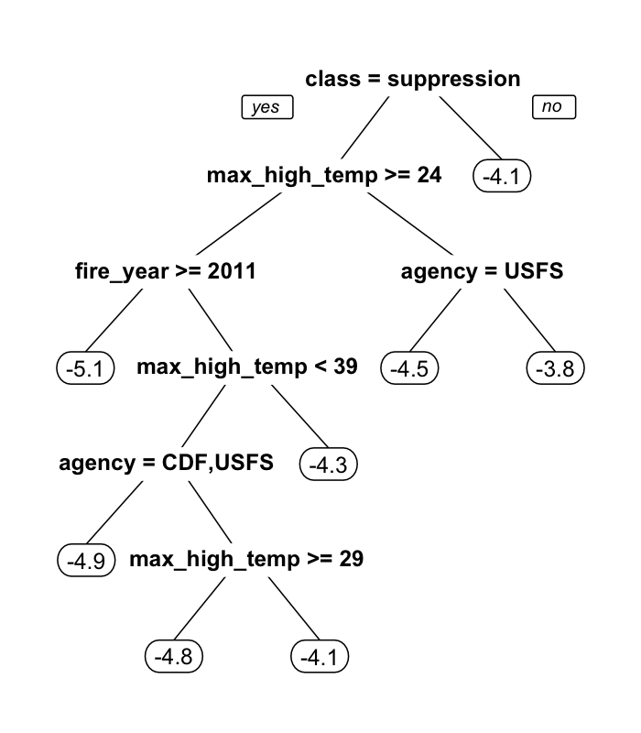

**Figure 2:** Relationship between ln(sdc) and percent high-severity (using a 90% basal area mortality threshold) and fire size (in ha). Fire class (suppression [SUP] vs Wildland Fire Use [WFU]) and managing agency (CAL FIRE [CDF], US National Park Service [NPS] and US Forest Service [USFS]) explain differences in ln(sdc) among fires with otherwise similar percent high-severity or similar fire size. Numbers in panel (a) correspond to fires used in Fig. 4 to illustrate different stand-replacing patch configurations with similar percent high-severity. Test statistics for inter-group comparisons given in text.

[1.5 column figure]

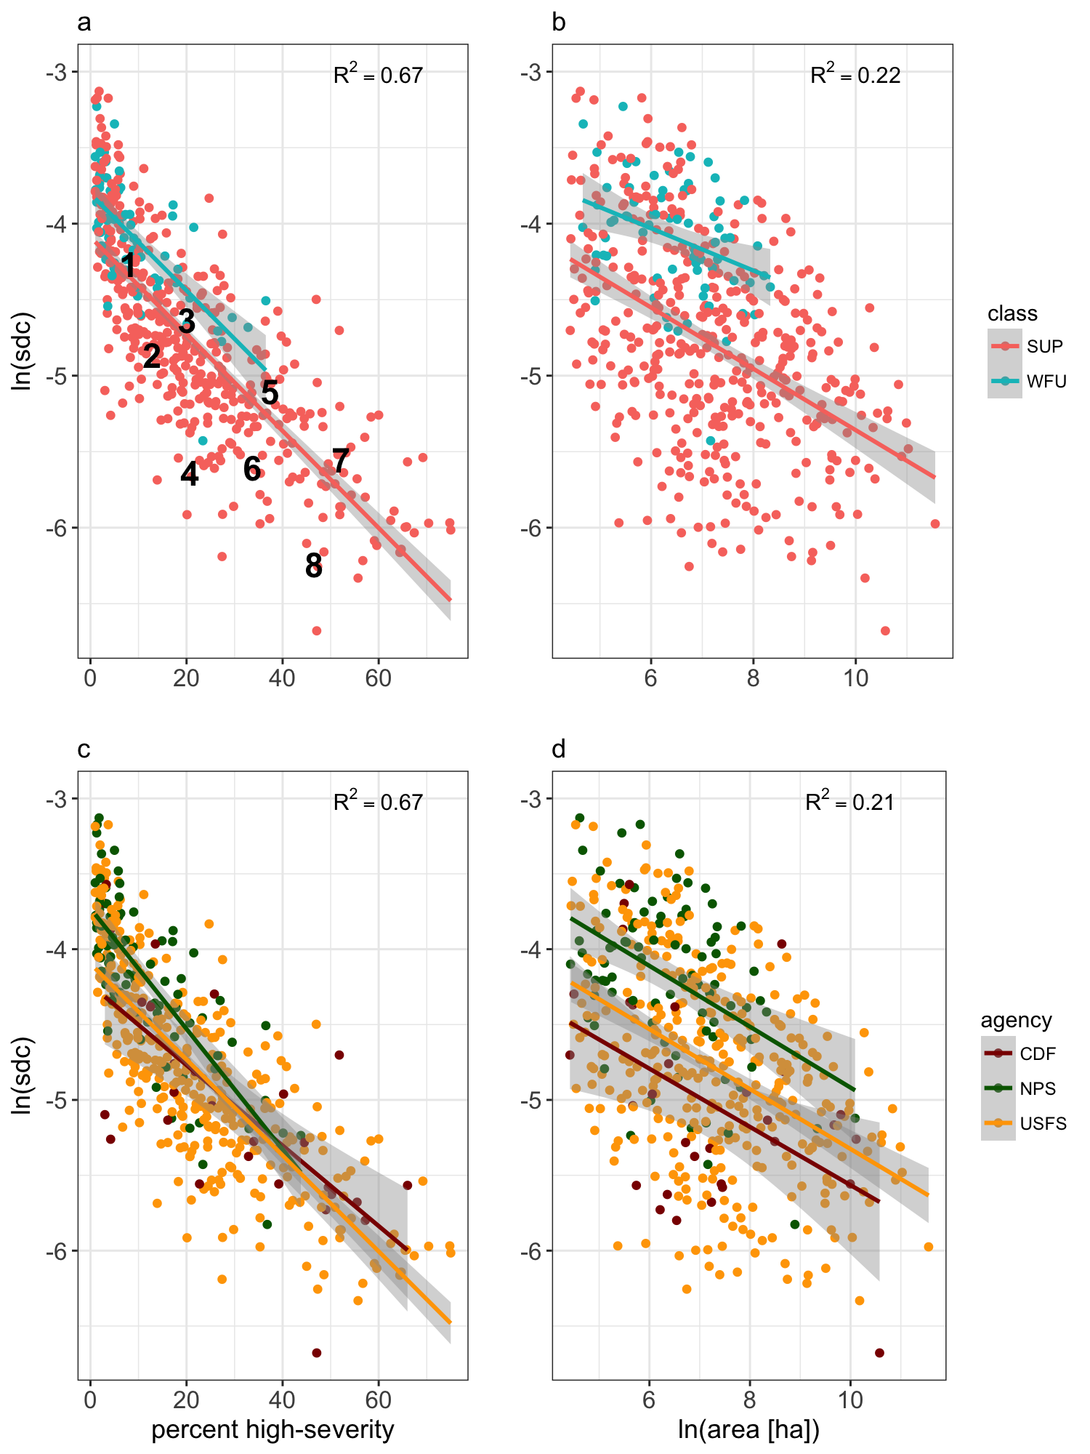

**Figure 3:** Trends over time in SDC mean annual (a), mean annual maximum burn index (c), and mean annual maximum high temperature during the burn window (e). Panels (b, d, f) show 5-year moving averages of annual data from panels (a, c, e) respectively.

[1.5 column figure]

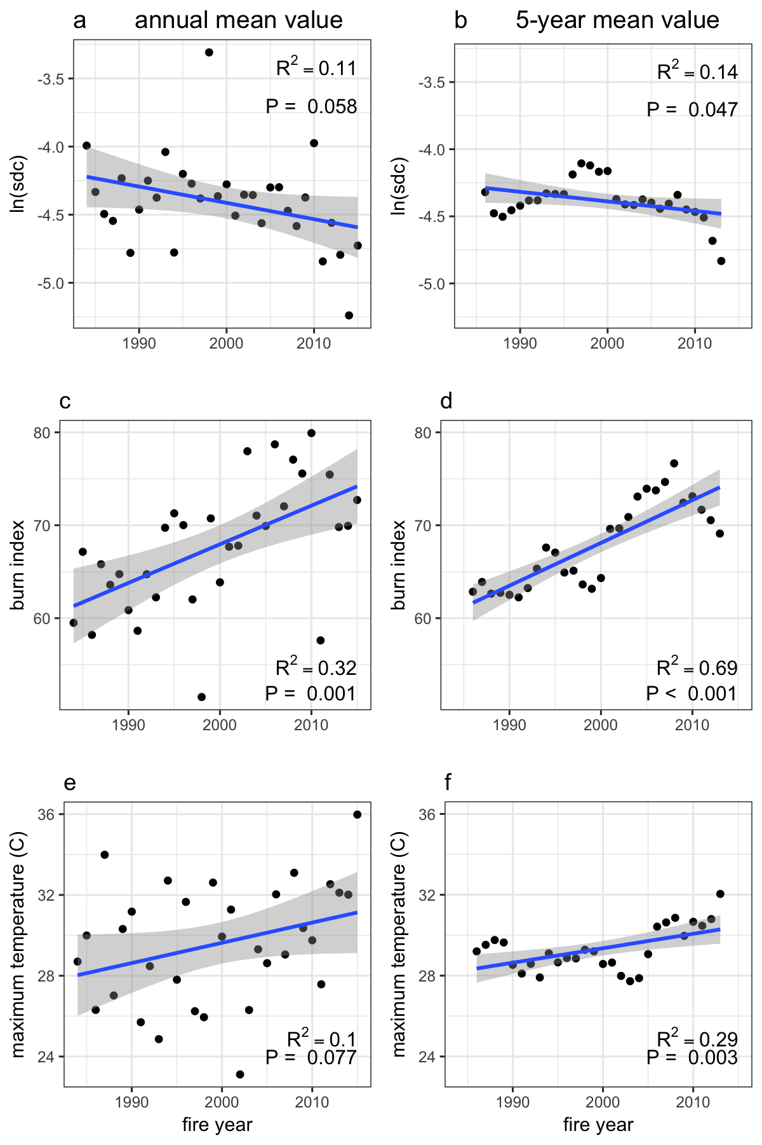

**Figure 4**: Examples of SDC for a range of fires. Fires in the same row have similar areas and percent high-severity, corresponding to numbers 1-8 in Fig. 3. SDC values are shown on figure. Fires in the right column have lower SDC values than comparably-sized fires in the left column.

[2-column figure]

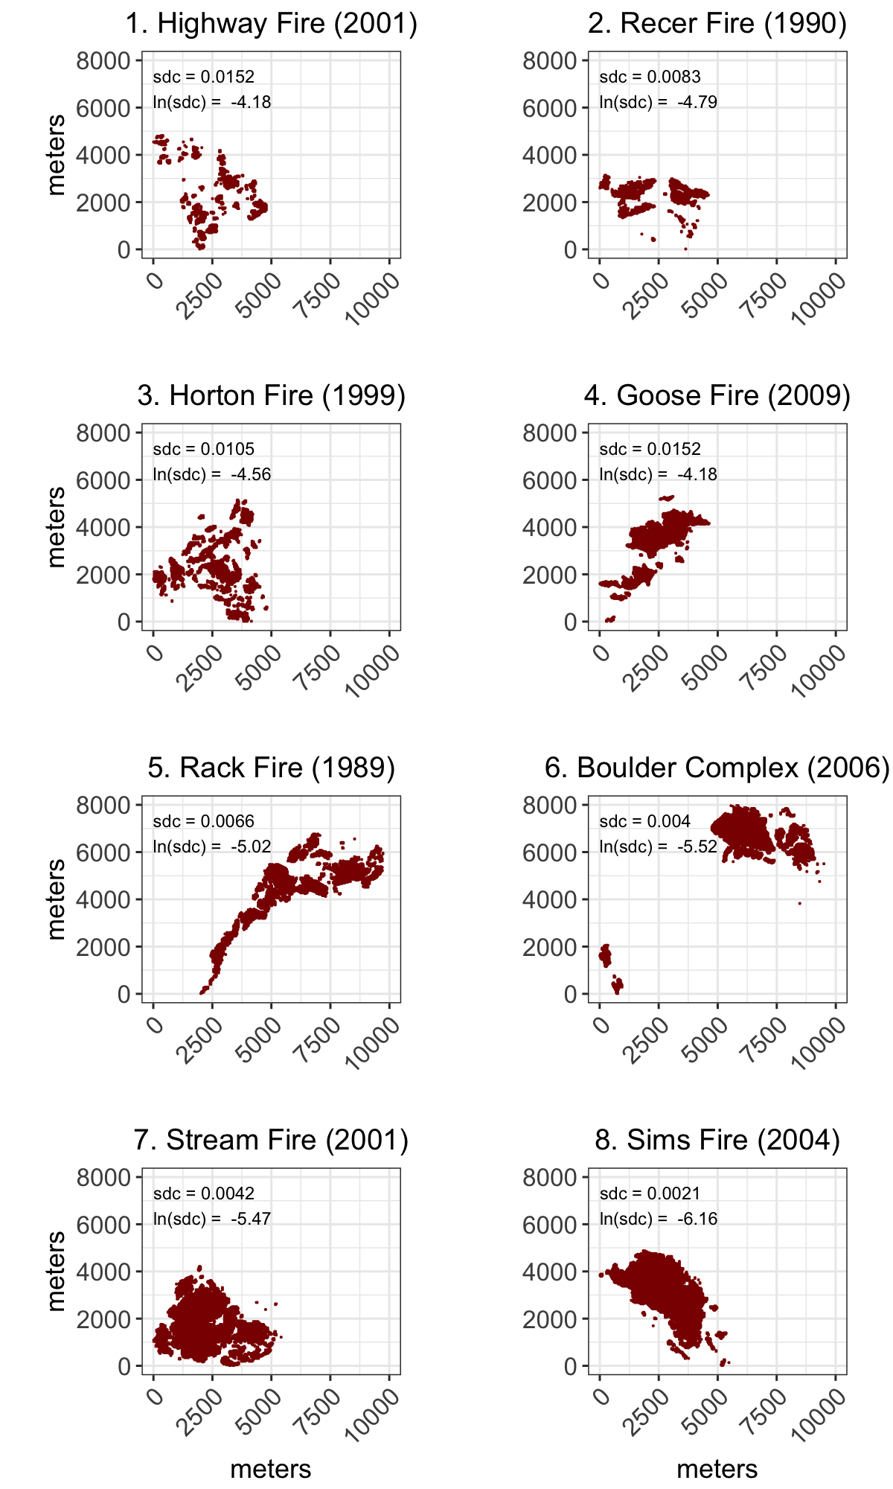

**Figure 5**: Increase in cumulative stand-replacing area greater than 120 m from edge over time, by agency (CAL FIRE [CDF], US National Park Service [NPS] and US Forest Service [USFS]).

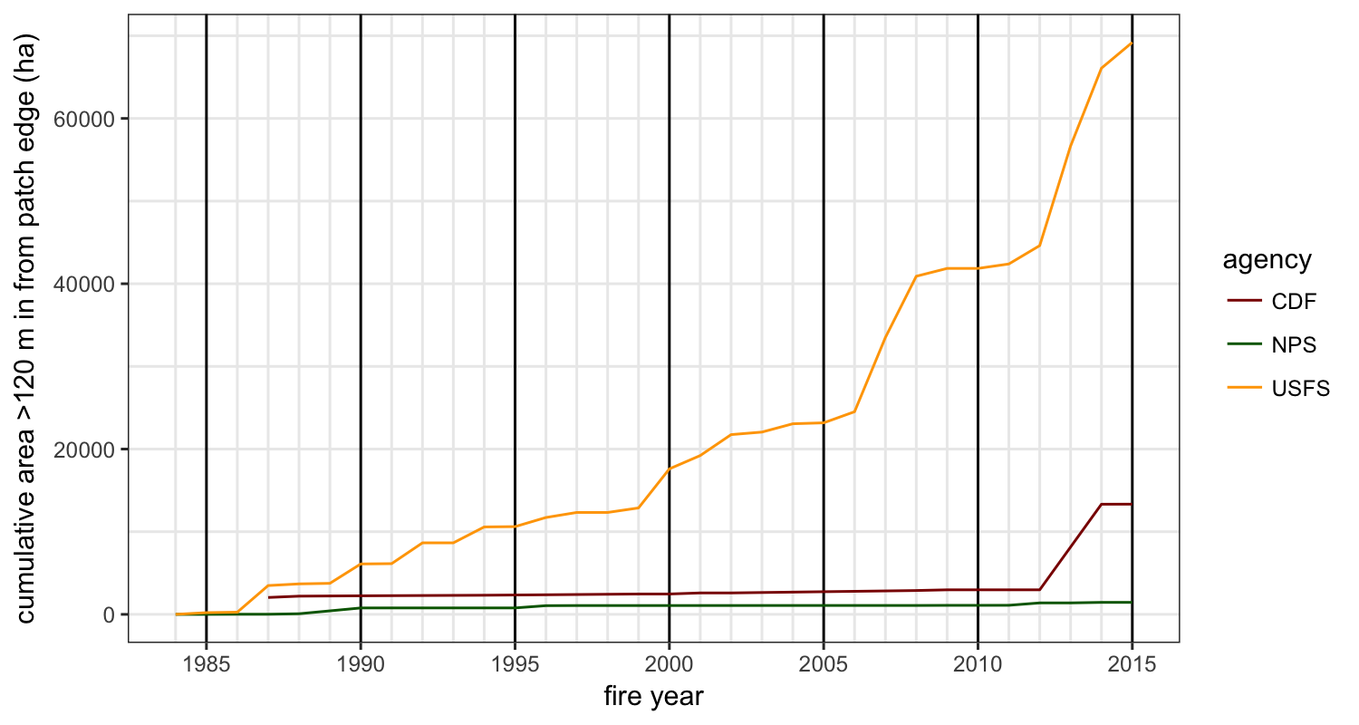

**Figure S1**: Range of possible SDC values as a function of average patch radius (radius given as *r* in m, area given as *a* in ha)

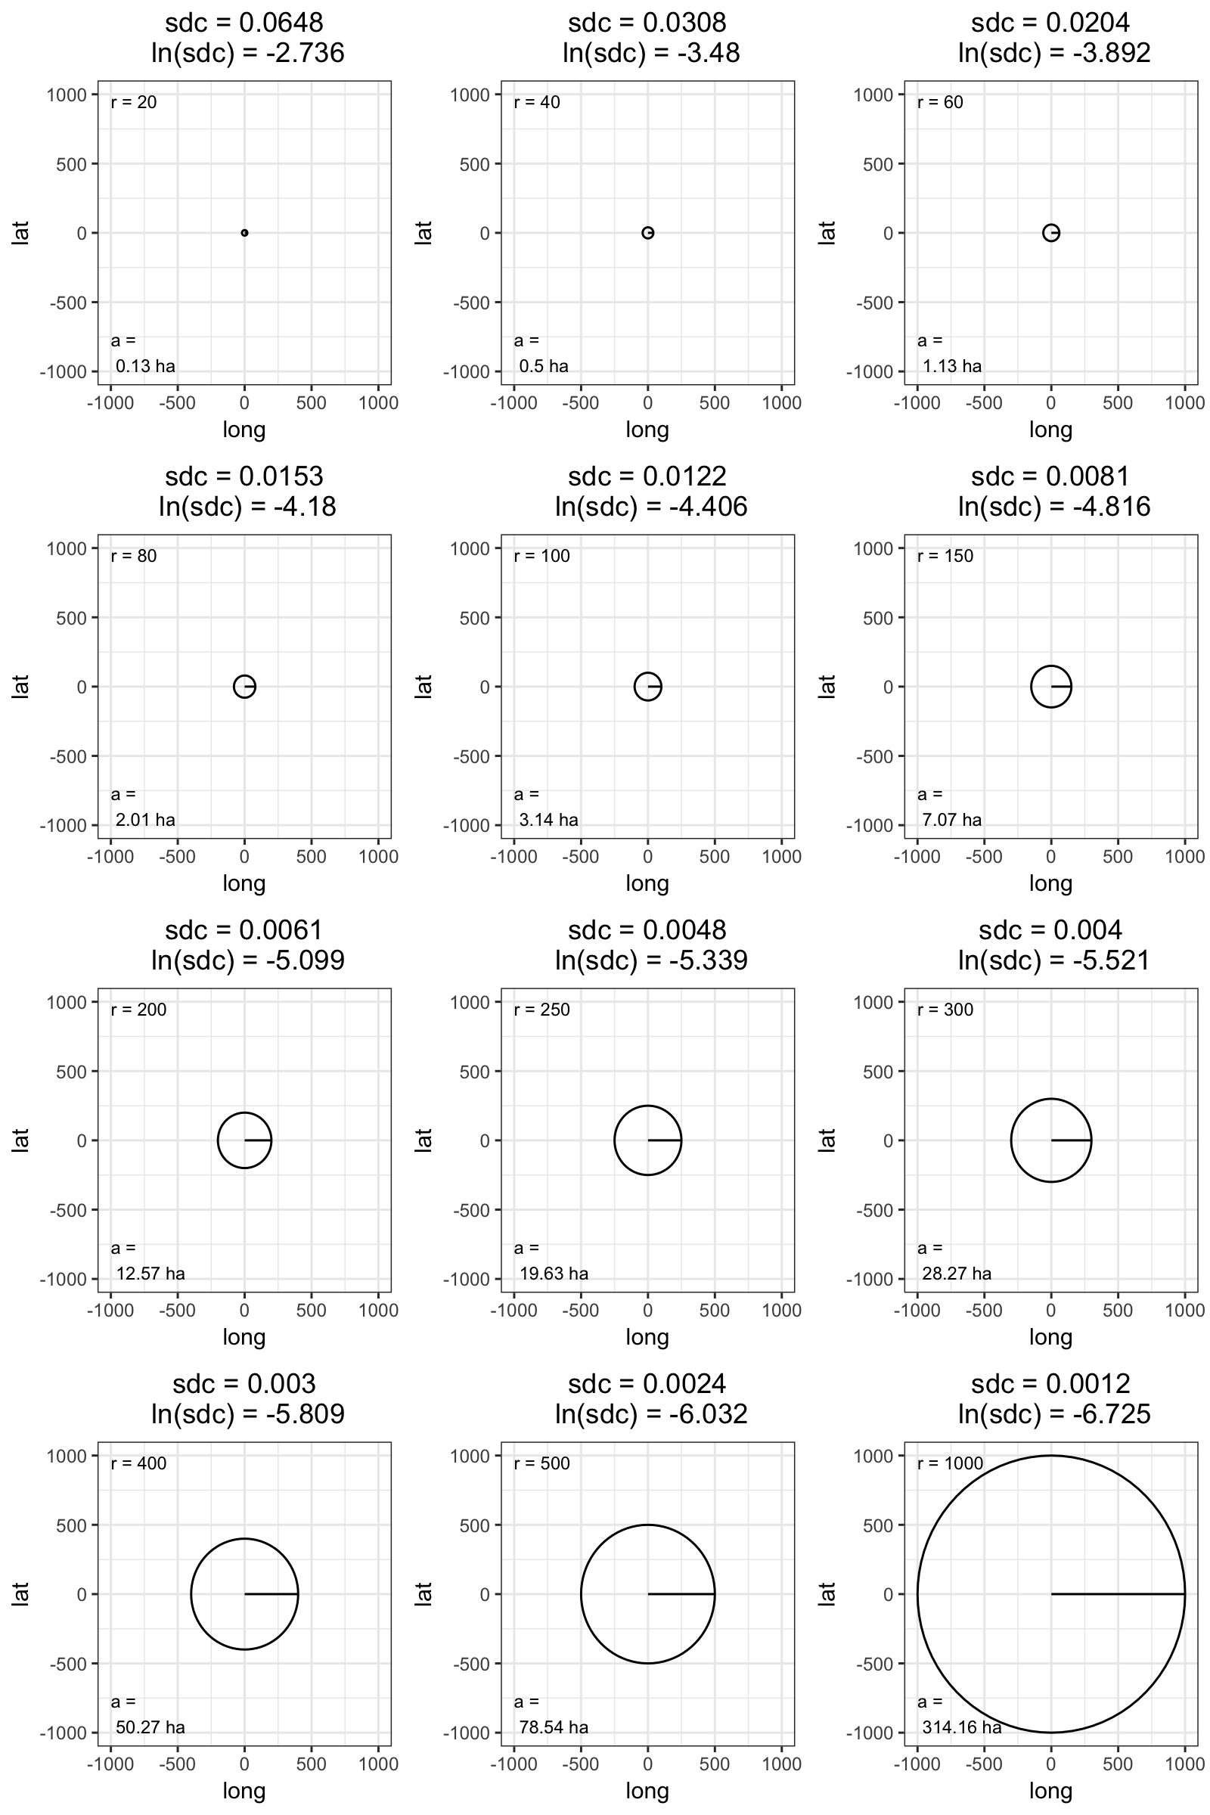

**Figure S2**: Change in ln(SDC) over time, distinguishing between the Southern Cascade/Sierra Nevada (SCSN) region and northwestern California (NW). The trend of decreasing mean annual ln(sdc) was significant in the SCSN (R2 = 0.12, t = 2.05, P = .049) but not in NW (R2 = 0.004, t = 0.32, P = .750). Neither trend was significant when the 5-year moving average was evaluated, although NW was marginally significant (R2 = 0.046, t = 1.14, P = .264 for SCSN; R2 = 0.16, t = 2.01, P = .057 for NW).

